Earl Thomas Skoe
From the “Centennial History 1903-2003” by Faye M. Estabrooks

Earl's parents were Ener Skoe and Lena Olson, both from Norway. His father proved up his homestead May 7, 1908, the day before he was married.

Earl Thomas Skoe was born August 19, 1909, on his father's homestead in Bergville, Ardenhurst Township, Itasca County, in the first frame house on Island Lake. After graduating from high school, Earl and his brother, Stanton, stayed at home and helped support their family. Earl spent many days clearing and grubbing stumps to increase the size of his father's farm. All ten Skoe children completed high school. Each of the eight youngest children attended one of the following: trade school, normal teacher's training, or college.
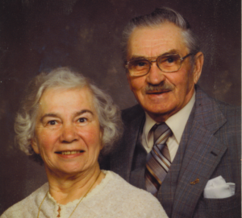
Earl Thomas Skoe (born 1909) and Vera Janet Urness (born 1919) were married May 9th, June 18th, 1939 at Hope Lutheran Church.
Earl was in the timber business all of his life—cutting, skidding and truck driving. For many years he was a buyer for many of the major pulpwood mills in Minnesota and Wisconsin. In the spring and summer of 1945, Earl employed 50-75 German war prisoners cutting pulpwood and cedar near Cass Lake. The pulpwood was used in papermaking; the cedar was for posts, shingles, and other uses.
Earl was active in civic and community organizations. He was a Northome City Council member from 1949-1978, and was mayor of Northome from 1978 through 1984. He served for 28 years on the Paul Bunyan Rural Telephone Association, nine of these years as vice-president, and was a member of the Minnesota Timber Producers Association for more than 30 years. Earl became a member and officer of the Northome Commercial Club when he moved to Northome in 1945.
Other civic involvements included membership in the Koochiching County Planning Commission and the Boy Scout Council, service on the Hope Lutheran Church Council in various offices, and vice-presidency of the Keep Minnesota Green organization.
Earl built the Maple Ridge Trailer Court in the spring of 1971 with five hook-ups. The first trailer was moved in during July 1971.
Earl Skoe died on Thanksgiving Day, November 24, 1994. Two of his brothers died that same month: Stanton of Kelliher and Raymond (R.C.) of Bloomington and Clear-
brook.

